Atomic Theory Revision, Question 8

\*An element is made of purely one atom.

\*Isotope have the same number as protons, but different numbers of neutrons.

\* GA(69)(31), GA(71)(31). You calculate the amount of neutrons by taking the small number away from the big number. EX, GA(69)(31) = 38.

\*Relative atomic mass of Ga – 60% Mass(69), 40%Mass (71)

\*(% x Mass) + (/ X mass) / 100. (60 x 69) + (40 x 71) / 100 = 69.8

\*The reason the numbers aren’t whole is because we are taking the relative abundances into account.

\*Relative atomic mass of MG(12)

\*78.7% Mass24 24-12 = 12Neutrons

\*10.13% Mass25 25-12 = 13Neutrons

\*11.17% Mass26 16-12 = 14Neutrons

\*The average mass of all the isotopes taking the relative abundances into account.

\*(76.7x24) + (10.13 x 25) + (11.17x26) / 100 = 24.3247

\*Melting point is a solid turning into a liquid.



\*The circles on either side represent 20. If the average room temp is more than the melting point yet lower than the boiling point, it is a liquid. If less than the melting point, it is a solid. If more than the boiling point, it is a gas.

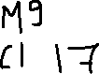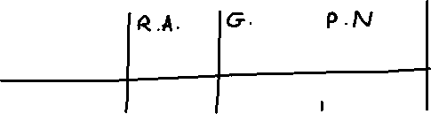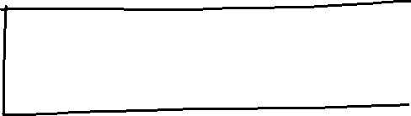

\*Na has the same group number as Mg.

\*Na and Mg have the same electrons in their outer shell in common.

\* There are 2 protons in an atom of magnesium.

\*Relative atomic mass is mass number – atomic number.

\*There are 1.3 neutrons in 10% of an atom of magnesium.

\*The two elements bond ionically.

\*The two properties of being ionically bonded are high melting point low boiling point.

\*An element is something made purely of one atom.

\*Group 8s are unreactive because they have a full outer shell.